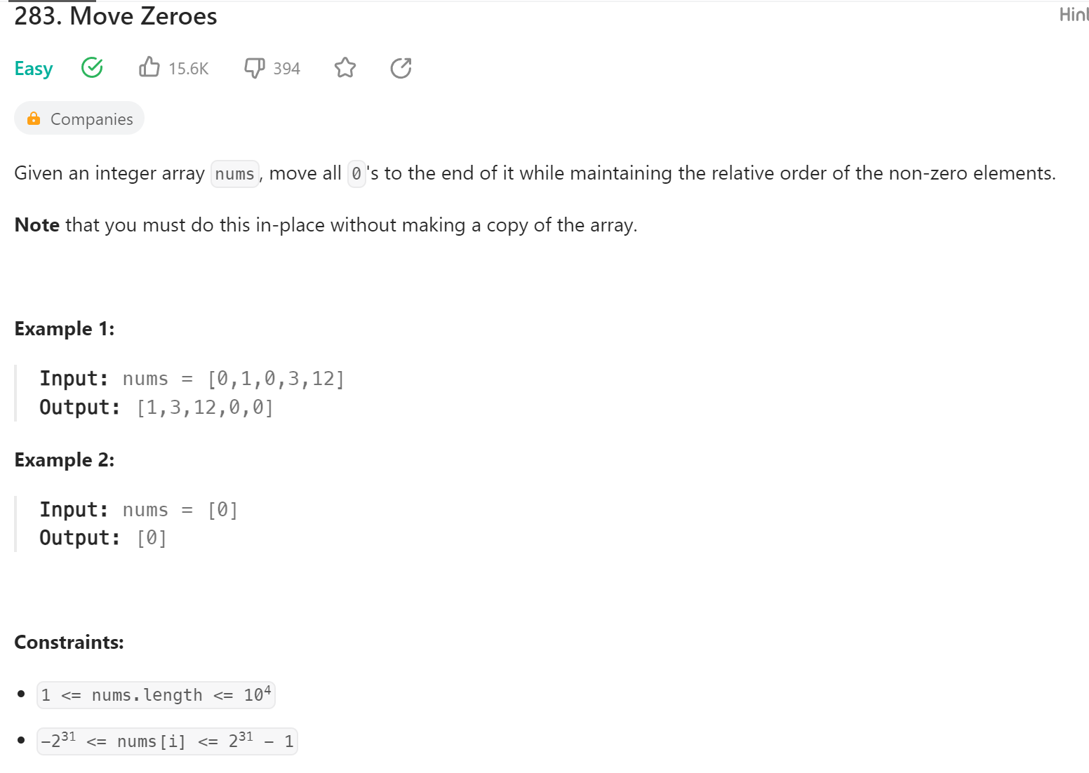  
**Follow up:** Could you minimize the total number of operations done?